Exclusive Opportunity to Acquire Sweden’s Leading Childbirth Education Company – Give birth without fear (Föda utan Rädsla)

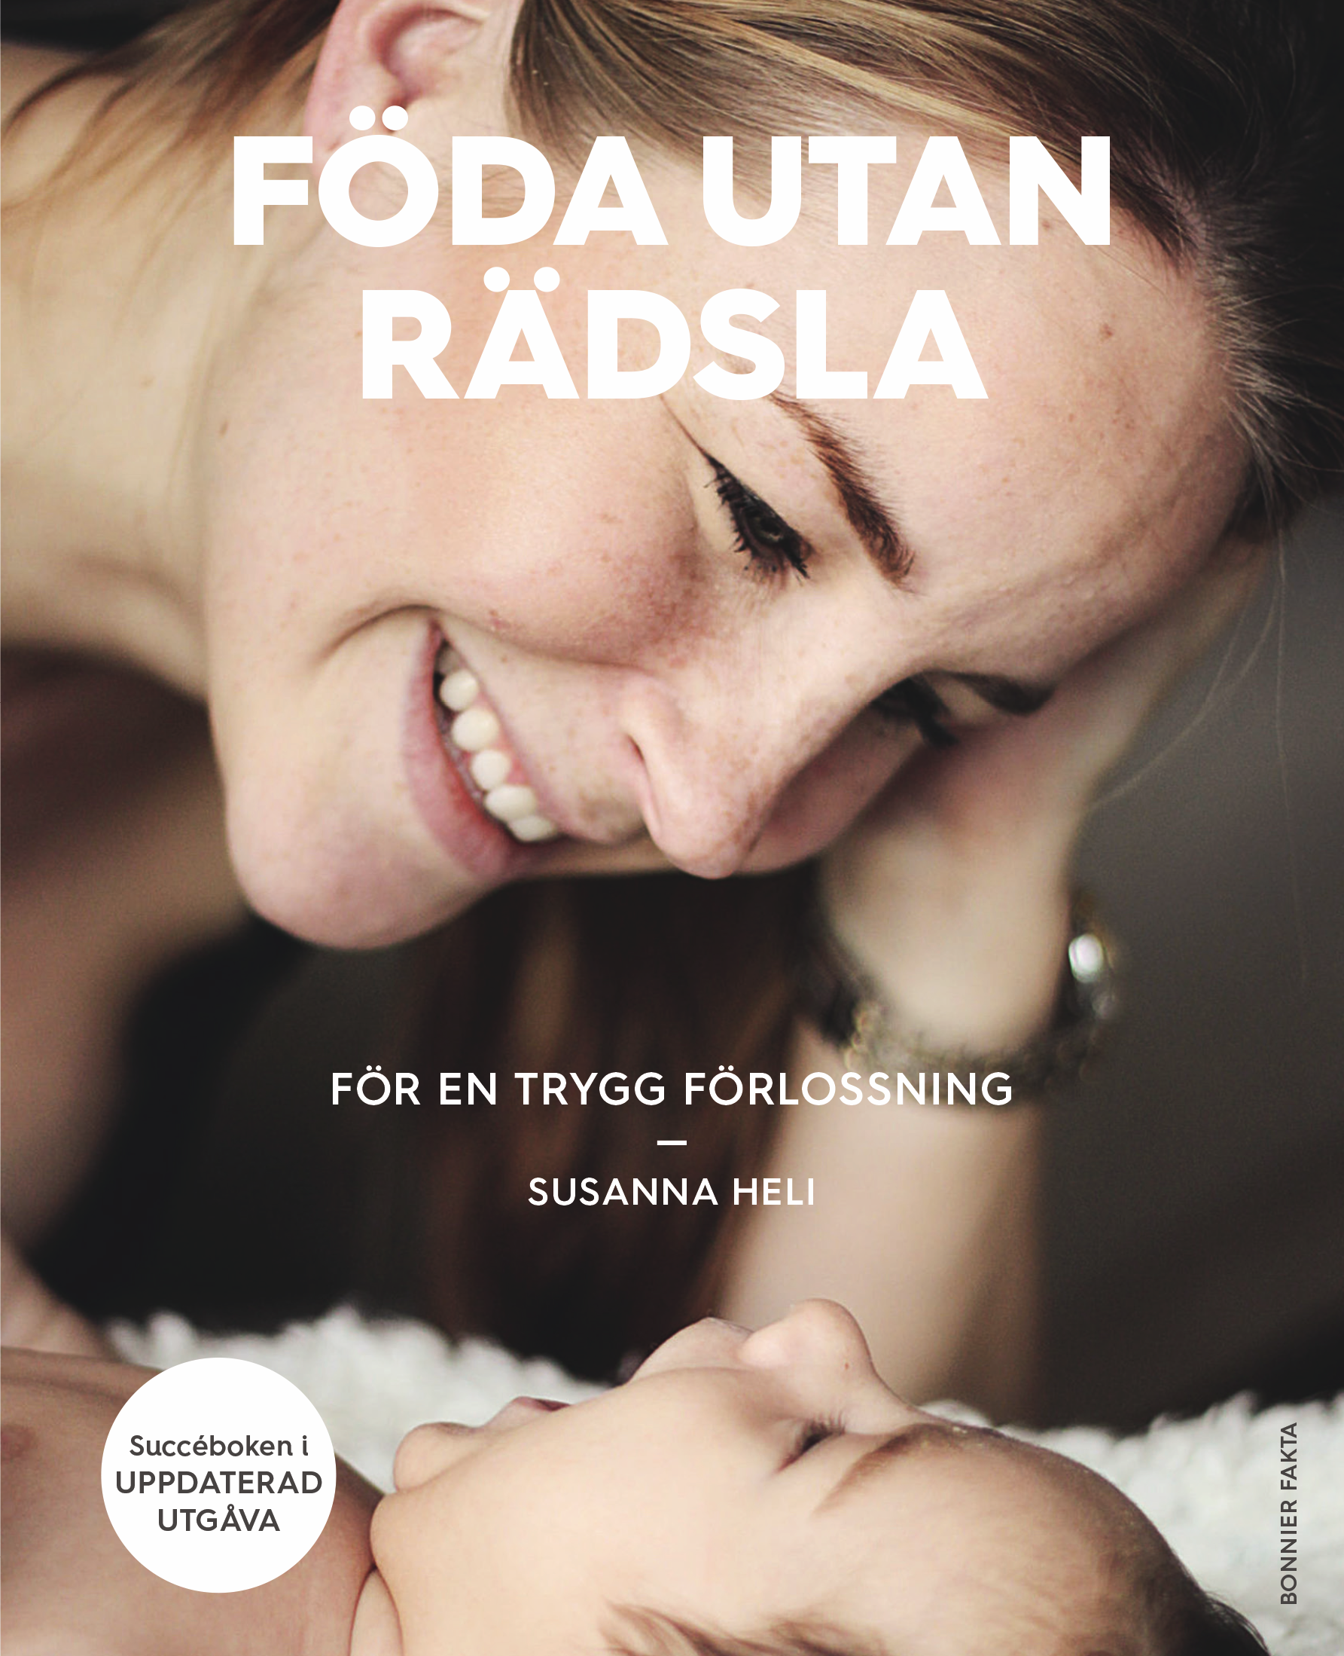

Introduction
Since 2009, Give Birth Without Fear (Föda utan Rädsla) has become Sweden’s most trusted and widely used childbirth method and book, with hundreds of thousands of copies sold. The book has already been published in several countries, such as Finland, and is planned to be published in Norway in 2026, with ongoing expansion throughout Scandinavia and Europe.
Over the years, our education programs, childbirth classes (Profylaxkurser), products, and app have significantly improved the birth experience for women and their partners, contributing to better maternal health and wellbeing.
The brand has established enormous credibility among parents, midwives, and healthcare professionals. Recently, results from a unique scientific study—the DIGI-EL research—have been conducted over several years and further strengthen the credibility of the method. This pioneering research shows positive results regarding the reduction of childbirth-related fear—an extensive problem that affects medical outcomes, birth experiences, parenthood, and future pregnancies.

By combining practical, hands-on methods with groundbreaking scientific validation, Föda utan Rädsla now faces a crossroads and is at the forefront of a new era in childbirth and maternal health.

An Opportunity
The method offers an innovative and scalable concept that appeals to both the public and private sectors, capable of rapid and effective expansion through small, strategic measures. With the right partner and targeted efforts, the method and digital tools can quickly be expanded, unlocking enormous potential within both sectors.
This is more than just a business opportunity; it’s a chance to be part of a concept ready to reshape childbirth education and maternal health in Scandinavia and Europe.

Our vision is that everyone has the right to a safe and empowering childbirth—regardless of how they give birth. We have the tools, methods, and model to realize this.

Our Current Situation
Since 2017, the business has been operated by founder Susanna Heli, who has developed the method, its products, services, and training programs, maintaining strong profitability and a solid market position.
During 2022–2023, a strategic investment was made into developing a digital product and app for scientific evaluation of the method.
To fund this initiative, the company used ALMI loans and crowdfunding, which—together with a deep recession—temporarily impacted our financial stability and profit margins. Fortunately, these investments have paid off—the app and related research have now been published with positive results. Although the company currently faces some financial challenges, this strategic development has placed us at a crucial crossroads.

We are therefore actively seeking an engaged partner who can help us leverage this significant scientific validation, scale up the business, and unlock its full global potential.

The Opportunity
We now offer a unique opportunity to acquire all or part of this well-established and innovative company. Our goal is to collaborate with someone who shares our vision—someone capable of accelerating growth, expanding our reach, and further developing our groundbreaking products.
Founder Susanna Heli will continue to be actively involved, providing ongoing support, strategic insights, and assistance with the further development of the method and business infrastructure—side by side with her new commitments and international assignments. This is not just a sale; it’s a strategic partnership.

With the right partner we can:
- Rapidly expand the reach of our scientifically backed childbirth courses, books, and educational programs.
- Leverage Give birth without fear (Föda utan Rädsla) proven success and international recognition across Scandinavia and Europe.
- Further develop the app with targeted applications for healthcare providers and the private sector, based on its solid scientific foundation and positive research findings.
- Capitalize on immediate growth opportunities through improved digital offerings, new markets, and product integration.

What’s Included
- Complete operation of childbirth courses (Profylaxkurser), including curriculum, branding, website, and booking system.
- An established and loyal customer base built over more than a decade.
- The well-known Give birth without fear (Föda utan Rädsla) book and expansion into Finland, Norway, and other parts of Europe. Rights to the books remain with the author, but an agreement will be created between the company and the author regarding royalties.
- Instructor training programs and ongoing educational resources.
- Marketing materials and operational manuals.
- Infrastructure to enable rapid scaling and future expansion.
- The scientifically validated app, with enormous potential for further development and applications within healthcare and the private sector.

Current Profitability, Scalability, and Growth Potential:
- Childbirth courses (Profylaxkurser) with a profit margin of approximately 60% per course.
- Online offerings (live and recorded lectures) with a profit margin of 80%, at a minimum of 10 couples participating.
- Training for healthcare professionals is offered regularly, and 14 regions in Sweden have been trained in the Give birth without fear (Föda utan Rädsla) care model.
- Other training programs, such as instructor courses and additional offerings, are provided annually.
- The ELSA app for childbirth, supported by scientific research, has enormous potential for adaptation to healthcare facilities, clinics, and private clinics, since it provides objective, evidence-based tools.
- Opportunities to develop additional digital products, online courses, and virtual platforms to broaden reach and impact.
- Scalability to new cities and international markets through leveraging digital channels and partnerships.
- Significant potential for collaborations, licensing, and brand expansion across Europe and beyond. New products, such as merchandise and other items, are also included in the plan.

Valuation and Investment
Although the core business has proven to be resilient and profitable, recent focus on app development, combined with current global economic challenges, highlights the need for an engaged partner to accelerate growth. Give birth without fear (Föda utan Rädsla) is the result of over 20 years of development, encompassing concepts, products, courses, and care models.
Due to its innovative nature and strong growth prospects, the valuation extends beyond traditional profit metrics. It reflects the method's unique, scalable potential to become the leading childbirth method in the Nordic region and internationally.

We are therefore open to discussing valuation and investment parameters, with a primary focus on forming a strategic partnership that accelerates our vision of global impact.

Contact & Next Steps
This is a rare, strategic opportunity to shape the future of childbirth education and maternal health. Are you interested in joining us at this exciting stage?
Contact:
Susanna Heli
Email: susanna.heli@gmail.com
Phone: +46 70 84 48 333
Web: fodautanradsla.se



